Customer Shopping Behavior Analysis
using Python, SQL, and Power BI

Project Type: Data Analytics Project

Submitted By
Name: Arpita Shaw
Course: B.tech
Department: Computer Science Engineering (AI & ML)
Reg. No.:
Roll No.:

1. Introduction
Customer behavior analysis is an important part of the retail industry as it helps businesses understand customer preferences, purchasing patterns, and market trends. By analyzing shopping data, companies can improve customer satisfaction, increase sales, and make better business decisions. In this project, customer shopping behavior is analyzed using Python, SQL, and Power BI to identify meaningful insights related to customer spending, product categories, subscriptions, discounts, and purchasing trends.

2. Problem Statement
A retail company wants to understand its customers’ shopping behavior to improve sales, customer engagement, and long-term loyalty. The company has noticed variations in purchasing patterns across different demographics, product categories, and shopping preferences. The main objective is to analyze customer data and identify factors such as discounts, subscriptions, reviews, and shipping preferences that influence customer decisions and repeat purchases.

3. Objectives
The main objectives of this project are:
- To analyze customer shopping behavior using data analytics techniques.
- To perform data cleaning and exploratory data analysis using Python.
- To answer business-related questions using SQL queries.
- To identify customer spending patterns and product trends.
- To compare customer behavior based on subscriptions, discounts, and demographics.
- To create an interactive Power BI dashboard for visualization and reporting.
- To generate business insights and recommendations for improving customer engagement and sales performance.

4. Dataset Description
The dataset used in this project contains customer shopping transaction records collected from a retail company.
Dataset Information
- Total Records: 3900
- Total Columns: 18
- Dataset Type: Structured Tabular Data
Features Included
Feature Name | Description
Customer ID | Unique customer identifier
Age | Age of customer
Gender | Male/Female
Category | Product category
Item Purchased | Purchased product
Purchase Amount | Total purchase amount
Review Rating | Customer rating
Subscription Status | Subscriber or non-subscriber
Shipping Type | Delivery method
Discount Applied | Whether discount was applied
Payment Method | Mode of payment
Previous Purchases | Number of previous purchases
Season | Purchase season
Frequency of Purchases | Customer purchase frequency
Location | Customer location
5. Tools and Technologies Used
Tool/Technology | Purpose
Python | Data analysis and preprocessing
Pandas | Data manipulation
SQL/MySQL/PostgreSQL | Business query analysis
Power BI | Dashboard development
Jupyter Notebook | Analysis environment

6. Methodology
The project was completed in the following stages:
Step 1: Data Collection
The retail customer dataset was imported into Python using Pandas.
Step 2: Data Cleaning and Preprocessing
- Handled missing values: The dataset contained missing values in the review rating column.
- Renamed and standardized columns: Column names were converted into snake_case format for readability and consistency.
- Removed redundant columns
- Created derived features such as age groups.

Step 3: SQL Analysis
- SQL queries were used to answer business-related questions and identify customer behavior patterns.

Step 4: Dashboard Development
- An interactive Power BI dashboard was created for data visualization and reporting.

Step 5: Insight Generation
- Business insights and recommendations were generated from the analysis.

8. SQL Analysis and Business Queries
SQL queries were executed to answer business-focused analytical questions.
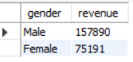
- Revenue Generated by Male vs Female Customers
This analysis used to understand purchasing differences across genders.

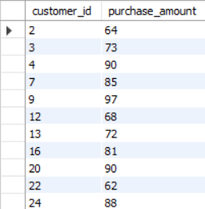
2. Customers Using Discounts but Spending Above Average
Insight: Discounts successfully encouraged higher spending among certain customer groups.
Business Value: Targeted discount strategies can increase revenue from premium customers.

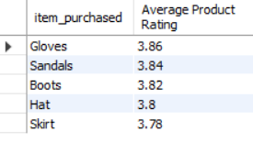
3. Top 5 Products with Highest Average Review Rating
This analysis identified products with the best customer ratings.
Insight: Highly rated products indicate strong customer satisfaction and product quality.
Business Value: These products can be prioritized in advertisements and recommendations.

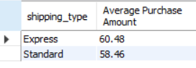
4. Comparison of Purchase Amount Between Standard and Express Shipping
Insight: Shipping preference influences customer purchasing behavior.
Business Value: Faster shipping options may encourage higher-value purchases.

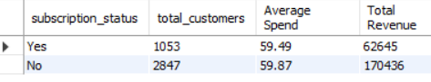
5. Subscriber vs Non-Subscriber Spending Analysis
This query compared:
- Average purchase amount
- Total revenue contribution
between subscribed and non-subscribed customers.

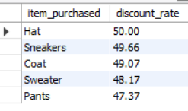
6. Products with Highest Percentage of Discount Purchases
This analysis identified products most dependent on discounts.
Insight: Certain products rely heavily on promotional offers.
Business Value: Helps optimize pricing and promotional strategies.

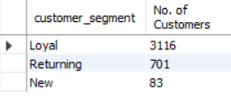
7. Customer Segmentation Based on Previous Purchases
Customers were segmented into:
- New Customers
- Returning Customers
- Loyal Customers
Insight: Most customers belonged to the returning customer segment.
Business Value: Different marketing strategies can be designed for different customer groups.

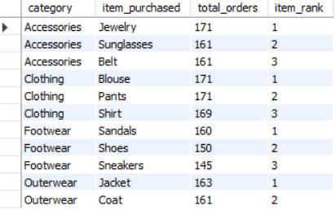
8. Top 3 Most Purchased Products Within Each Category
Insight: Some products consistently dominated customer purchases.
Business Value: Supports inventory planning and product promotion strategies.

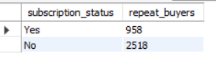
9. Repeat Buyers and Subscription
Insight: Customers with more previous purchases were more likely to subscribe.
Business Value: Loyal customers should be targeted with subscription and loyalty programs.

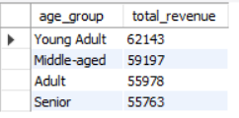
10. Revenue Contribution by Age Group
Insight: Young adult customers contributed the highest revenue.
Business Value: Marketing campaigns can focus on high-value age groups.

9. Power BI Dashboard
An interactive Power BI dashboard was developed to present analytical insights visually.
KPI Cards
- Total Customers
- Average Purchase Amount
- Average Review Rating
Dashboard Components
Charts and Visualizations
- Revenue by Category
- Sales by Category
- Revenue by Age Group
- Sales by Age Group
- Subscription Distribution
Filters/Slicers
- Subscription Status
- Gender
- Product Category
- Shipping Type

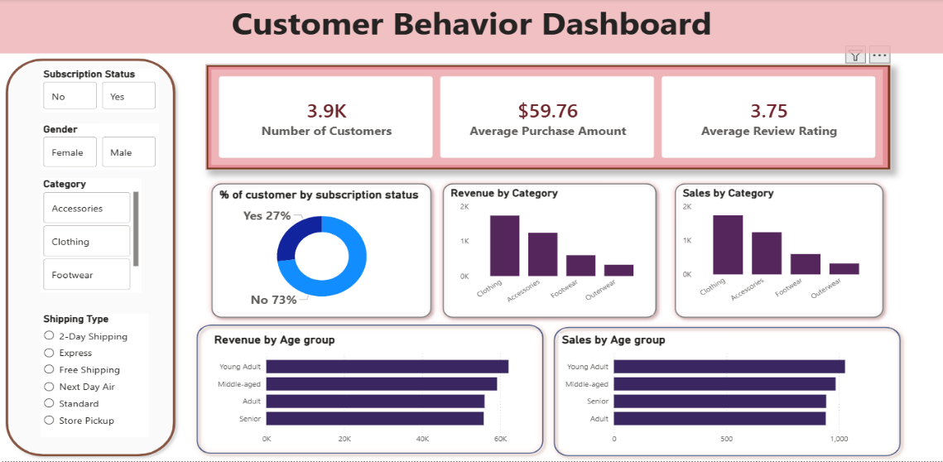

10. Business Recommendations
Personalized Marketing: Target high-value customers using customer segmentation.
Smart Discount Strategy: Use discounts strategically to increase sales without reducing profit margins.
Promote Top-Rated Products: Feature highly rated products in campaigns and recommendations.
Loyalty Programs: Reward repeat buyers to improve long-term retention.
Inventory Optimization: Maintain higher stock levels for best-selling products.
Age-Based Campaigns: Design marketing campaigns targeting high-revenue age groups.

